STOCKLISTING APP CASE STUDY

1 Name of the Project Stocklisting App

2 Objective
Develop a StockListing Application that allows users to view all stocks available in a country, and save stocks to favorites/wishlist.
The application needs to fetch stock details by registering with the following API
https://twelvedata.com/

Functional
3 Requirements

4 Non-functional
Requirements

5 Technical
Requirements

Tools and
6 Technologies to be used
Sample API:
https://api.twelvedata.com/stocks?country=<country_name>
1) User Interface (UI) should achieve the following:
a) User Registration b) User Login
c) List all stocks available based on country name d) Add a stock to your favorite list
e) View favorite stocks.
f) UI should be responsive which can run smoothly on various devices.
g) The UI should be appealing and user friendly
1) The app should be able to load stock details quickly and smoothly, even on low-end devices.
2) The app should be able to handle a large number of users without slowing down or crashing.
3) The app should be easy to use and navigate, even for users with no prior experience with stock apps.
4) The app should protect user data from unauthorized access, modification, or deletion.
1) Application should be developed using Microservices in the Backend.
JWT tokens to be used for securing the Backend.
2) Frontend should be developed using Angular/React.
3) Microservice patterns like API Gateway, Service Discovery, Microservice communication, Configuration Server should be used.
4) Comprehensive Unit tests and integration tests with coverage should be implemented to validate the functionality of the Application.
5) Application should be integrated with SQL databases on Cloud.
6) Application should be deployed on AWS Cloud.
7) SCM like Gitlab to be used for regularly committing the source code.
8) Implement Documentation of API using Swagger/Open API.
9) Application should be integrated with the CI/CD process on AWS. SCM : Gitlab
Middleware : Spring Boot
Frontend : Angular/React
Data Store : MySQL
Testing : JUnit, Jest/Jasmine
CodeQuality : Sonar Lint, JaCoCo
CI : Gitlab/AWS/Jenkins
API Documentation : Swagger
Message Bus : RabbitMQ/Kafka Containerization : Docker, Docker Compose Cloud : AWS

User Stories

1 As a user, I should be able to register with the application so that I can login and use the functionalities of the application.

2 As a user, I should be able to login with my username and password in order to access the functionalities of the application.

3 As a user, I should be able to view all stocks based on country name using Third Party
API.

4 As a user, I should be able to save stock details to a wishlist/favourite so that I can access them later.

5 As a user, I should be able to access stock details saved to my wishlist/favourite.

6 As a user, I should be able to delete stock details saved to my wishlist/favourite.

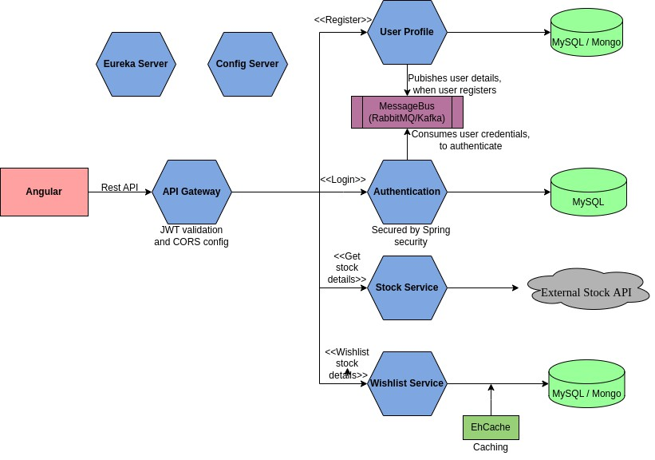High Level Architecture Diagram

The responsibilities of the microservices in the above figure are as follows:

• User Profile Service: This Service is responsible for storing user registration details. The Service publishes the user credentials sent as part of registration to the message bus and stores the remaining user profile information in the database.
• Authentication Service: This Service is responsible for consuming user credential from the message bus and storing it in the database. When a user logs in, this service validates the login credentials against
the credentials stored in the database. If the credentials matches, this service generates a JWT token and sends back as response, else an error message is sent.
• Stock Service: This Service is responsible for accessing an external Stock API to fetch stock details based on the country name coming in as a request and returning back the list of stocks as response.
• Wishlist Service: This Service is responsible for storing stock details bookmarked by users in the database.
• API Gateway: This Service acts as the entry point of the system. It intercepts all the requests and validates the JWT Token before routing it to the appropriate microservices.
• Eureka Server: This Service acts as a service registry where all the other microservices registers during startup for discoverability.
• Config Server: This Service acts as a centralized location to store the configuration of the other microservices of the system.

Recommended Steps to complete the Case Study

Step 1: Understand the Case Study
Step 2: Identify the Data Model and draw the data flow diagram
Step 3: Draw the UI Wireframes Step 4: Create the Boilerplate Step 5: Setup CI/CD Pipeline
Step 6: Implement and write test cases for the backend Step 7: Implement and write test cases for the frontend Step 8: Integrate the frontend with the backend
Step 9: Dockerize all services of the application
Step 10: Configure Docker Compose for Container Orchestration
Step 11: Deploy to Cloud

Deployment

i) The backend services and frontend services should be deployed on EC2 instances. ii) Cloud SQL Databases to be used.

